Behaviour Recording Prompt Sheet
Incidents of behaviours of concern are recorded on CPOMS within 24 hours of the incident (Same day if RPI/seclusion used). Where a restrictive physical intervention/seclusion has been used, a bound and numbered book reference number MUST also be included. SLT should be informed at the time and parents notified in person. The CPOMS behaviour incident form should only be used for behaviours witnessed in school. Where information is given about behaviours at home or on transport, this should be recorded as parental contact or multi-agency contact.

How to record a behaviour incident

1. | Enter student name.
2. | Enter date and time.
3. | Select ‘behaviour monitoring’ category. There are two options (behaviour - resulting in injury, behaviour – other). One or both categories must be ticked.
4. | Select sub-categories. | 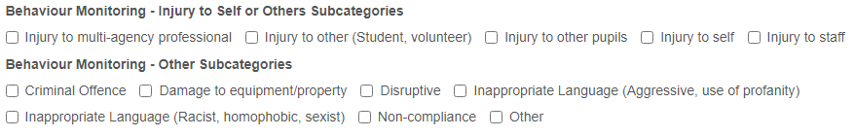
5. | Record details of actual behaviour incident. Remember to consider the language used. | 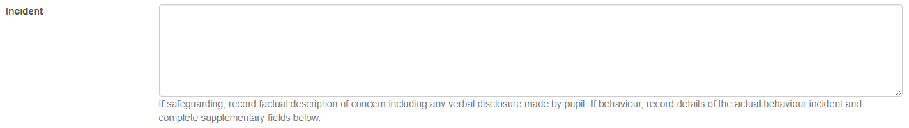
6. | Select behaviour tier (Use best fit approach). | 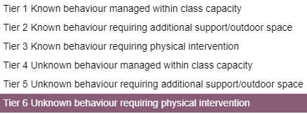
7. | Select de-escalation strategies used. | 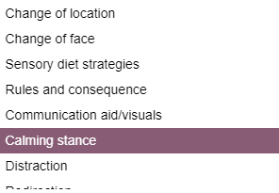
8. | Select if first aid was required.
9. | Enter location of behaviour incident.
10. | Select activity at time of behaviour incident (Use best fit approach). | 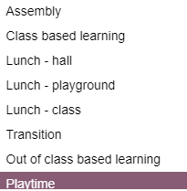
11. | Enter any follow up actions required.
12. | If used, select physical intervention strategies/seclusion used. More than one may be selected if needed. This incident MUST be recorded in the bound and numbered book and the reference number included with the incident. A member of SLT and parents MUST be informed.
13. | Enter staff involved in incident.
14. | Enter if pupil has current ABSP.  Where a pupil does not have a current ABSP, physical intervention maybe used as an emergency. The SLT and the behaviour lead should be notified. A meeting should be scheduled with parents to discuss behaviour strategies.

